# **How Much Does it Cost to Outsource App Development?**

The world is a digital playground. Business thrives online in many shapes and forms. To succeed in this new modern landscape, business owners need mobile apps. The app development process for making your own app is stressful. A lot of time and money goes into the design, testing, and implementation.

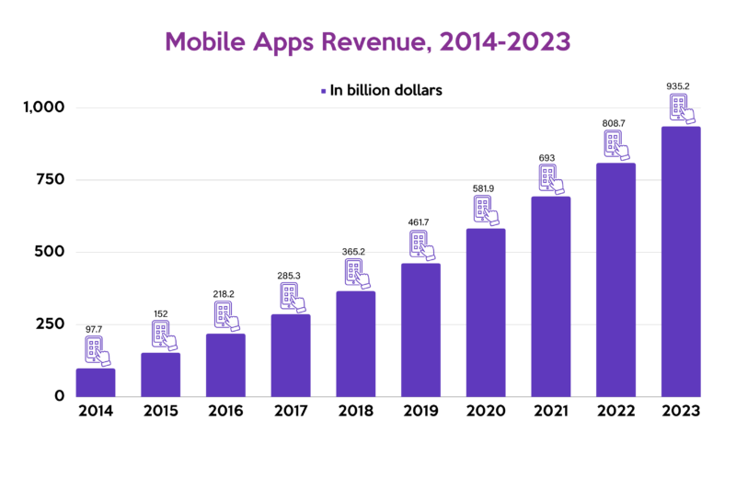

[Source](https://mindsea.com/wp-content/uploads/2022/02/Screenshot-18-1024x585.png)

Hiring your own mobile app development team almost seems essential, but could it be over the top? The alternative may be easier. Rather than hire an entirely new department, outsource to a third-party service provider. But how much does it cost to outsource app development?

## **Why Should You Outsource the Mobile App Development Process?**

App development is a multi-faceted project. Successful business app development takes a great deal of experience, training, and the right tools. Outsourcing offers a wide variety of benefits and promises a high-quality product with less in-house action.

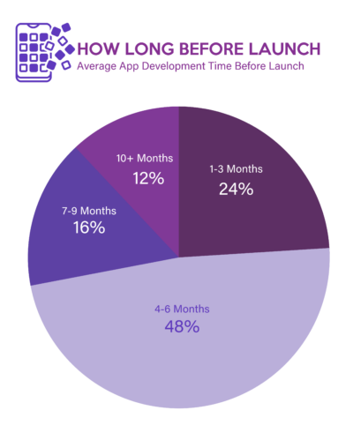

[Source](https://www.mobileappdaily.com/public/uploads/mad_5796216df7.png)

If you’re considering taking mobile apps out-of-house, take a look at this list of potential advantages when you outsource mobile app development.

### **Saved time**

During business hours every moment is precious. The age-old adage that time is money rings as true now as it did when it was created. When you take time away from the management of day-to-day operations, you risk the loss of revenue, no matter your industry.

There are a lot of hours to be lost to mobile app development if you keep it in-house, including:

* Vetting and hiring by HR
* Training and scheduling new employees
* Setting up payroll and benefits
* Obtaining the necessary equipment and software

When you Outsource mobile app development a little elbow grease is still required. You’ll also spend time talking over design goals. Even then, the overall amount of time spent on the project will be far less when outsourced.

### **Fewer bugs**

It’s only human to take mistakes. When your business app is on the receiving end, it could mean trouble. Your business app is another doorway to your company.

Customers use this door to look at products and services, get in touch, or make a purchase. If the app doesn’t work, customers can’t shop, and the app becomes obsolete.

Working with a professional app designer ensures fewer bugs and a higher rate of app success.

### **Access to expertise**

Working with a team of experienced app designers offers you a front-row seat to new expertise. Things you didn’t know before will suddenly be shared. You’ll gain access to information, tools, and other supports you didn’t have before.

### **Fewer training requirements**

Outsourcing mobile app development means less training. A mobile app development team already know how to build an app. Chances are, they work with other businesses like yours across a wide range of industries. This knowledge and experience vastly reduce the need for you to step in and train developers.

You’ll save energy in areas including:

* Helping app developers transition from training to the workspace
* Creating training routine
* Deciding on paid or unpaid training
* Buying training materials
* Hiring or training a training manager

You may need to offer some guidance on brand voice and company culture, but not to the level of a new employee. Your mobile app development company will work with you to develop the app that best speaks for your brand.

### **Ease of expansion**

Finally, the growth of your app is important to consider. Outsourcing app development keeps you connected to a development team that is constantly evolving with the latest and greatest app trends. As your brand grows with the modern business frontier, your app can grow too.

Outsourcing app development ensures your app is always moving with the times. If it needs to be bigger, better, or offer more, you have a team ready to supply it.

## **What Impacts the Cost of Outsourcing Mobile App Development?**

App development isn’t a free venture. There are many costs to factor into the decision to produce an app. Outsourcing app development isn’t a static service. Depending on the outsourcing company you choose, and the product you order, the app development cost varies.

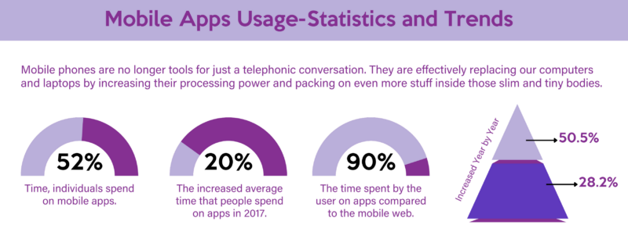

[Source](https://cdn-infographic.pressidium.com/wp-content/uploads/Infographic-MOBILEANDWEBSOLUTIONS-29May17-480x460.jpg)

Here are some of the things that impact the overall app development cost when outsourcing to a development team.

### **Use and features**

Almost anyone can make a basic app these days. It’s when you begin diversifying that app to include proper internet navigation, with multiple pages, features, and uses that you need experienced developers.

The desired use of your app, and the technology and features that go into creating it, play a big part in app development cost. The more bells and whistles, the higher the bill.

### **Security level**

If your app is used for e-commerce, customers are loading personal information, including address and credit card details. There are many mobile apps that require important, and private details, to be stored for optimum use.

High-security levels keep this information safe, but it comes at another app development cost. The more intense your security setup, the more you’ll pay for mobile app development.

### **Location of developer**

Anytime you outsource a project you have the option to send it domestically or internationally. In many cases, local outsourcing partners within the U.S. are more expensive than international ones.

You need to weigh the pros and cons of going out of the country for your app development. Think about what that means for language, availability, and customer service. It might be worth the extra app development cost to stay in North America.

### **Service availability**

Availability and location are often intermingled, but not always. App development isn’t a one-and-done kind of situation. True, the major cost of the project is app design and creation. But, there’s ongoing maintenance to consider.

If there’s a bug, the app goes offline, or you simply want to add a new feature and need to chat, availability is important. You’ll pay more for a company offering overtime services or a 24/7 contact center than a regular 9 to 5 operation.

### **Customization level**

All app design has a certain level of customization. It’s when you get in-depth with these bespoke features that things grow in cost. If you want an app with a novel navigation system, videos, interactive features, and other customizations, you’ll pay more.

### **Hosting and upkeep**

When you find an app developer, you want nothing more than a designer. Perhaps you have an in-house team ready to tackle maintenance. Maybe you have a server that you’ll run the app from. Maybe not.

The level of ongoing interaction required when you outsource app development impacts price. If you outsource these things, you’ll pay more but deal less with the time-consuming task of app management.

### **In-app purchasing options**

Offering in-app purchasing is heading into e-commerce territory. This involves a higher level of privacy and security features. It also involves linking products and prices from your website to your app. Producing a working inventory takes time. This will add to the budget of your app design.

## **Average Costs to Outsource App Development**

Outsourcing app development is different than outsourcing marketing or customer service. The bulk of the app development cost is involved in the design and implementation of the app. You’ll pay the most for your app in the design and build stages. ‘

On average, you can expect to pay anywhere between $50 to $130 an hour to outsource app development. This is true between Apple and Android apps. This ensures app development cost fluctuates from project to project based on developer experience and hours needed to complete the task.

Small businesses: App development is less about the size of a company and more about the level of complexity involved. Here’s a breakdown relating to company type.

1. Small companies: Small businesses looking for a simple app can expect to spend somewhere between $10,000 and $80,000 for app development.
2. Mid-sized companies: Mid-sized businesses with a medium range of app complexity will spend in the range of $60,000 to 120,000
3. Large corporations: Big companies looking for apps with all the bells and whistles will pay the most. An extremely complex and customized app could run anywhere from 120,000 upward.

Different providers offer different development fee structures. You might find one with packages that allow more room for customization with less impact on your wallet. Shop around to find the right fit.

## **Outsourcing App Development vs. In-House App Development – Direct Comparison**

An app developer’s salary changes by state and education level. According to [Glassdoor](https://www.glassdoor.com/Salaries/new-york-city-app-development-salary-SRCH_IL.0,13_IM615_KO14,29.htm), you can expect to pay roughly $137,510 annually for a single in-house developer. If you’re contemplating an in-house team, this changes things.

Salary, benefits, training, and other app development costs add up to make hiring a single developer potentially more costly than outsourcing the entire project. Let’s take a look at other app development costs that go into an in-house team.

### **Initial setup app development costs**

Getting an in-house app team started requires some resources, including:

* Equipment: $3,000 to $6,000
* Software: $500 to $3,000
* Office space: $25,000 annually (depending on the square footage of the commercial space).
* Furniture: $300 to $2,000 depending on the type of furnishings you choose
* HR services: $26 to $33 hourly for vetting, interviewing, and onboarding new employees through HR.

Already, the growing costs put outsourcing in a positive light.

### **Ongoing expenses**

There are more costs than the initial start-up fees to consider. Ongoing expenses are any costs that continue through the life of your app, such as:

* App maintenance: Hourly pay of $50 to $130.
* Equipment maintenance: 5% of the cost to replace your equipment goes into maintenance every year.
* Ongoing training: Training costs change based on the type of training and materials required.
* App development project manager: [$156,150](https://www.glassdoor.com/Salaries/new-york-city-app-development-manager-salary-SRCH_IL.0,13_IM615_KO14,37.htm) annually.

Not all in-house app development needs a department manager. If you only hire one app developer, there’s likely no need for this role.

### **Total cost of ownership**

Looking at the initial startup and ongoing costs, you could spend somewhere around $463,970. This is the potential cost including two developers and a project manager. Again, this app development cost will change based on how many new employees you hire.

Looking at this number, and even removing the manager from the equation, the overall app development cost of an in-house development team far outweighs that of outsourcing.

## **Choosing the Right App Development Outsourcing Provider**

Now that we’ve explored the cost of outsourcing and in-house app development, it’s time to talk about finding the right outsourcing company. Outsourcing your app is a big decision. Your app is part of your brand. It tells customers who you are and helps you interact regularly.

Look for app developers known for their expertise in the field. We recommend [The New Workforce](https://thenewworkforce.com/). At The New Workforce, you can count on a team of professional app developers ready to incorporate your brand into the design. The company also specializes in marketing, sales, customer service, and IT outsourcing, making them an invaluable partner.

As you hunt for the right fit for your app, here are some characteristics to consider.

### **Reputation and experience**

You put the reputation of your brand into the hands of your app developer when you choose between mobile app development companies. This means your reputation may be a reflection of theirs. Look at ratings and reviews and see where the developer stands with their customers.

Experience is another important factor when selecting an app developer. Apps are constantly evolving to include new technology and functions. Choose a developer with relevant and up to date training and experience in your industry.

### **Quality of app**

Not all apps are created equal. Developing an app and developing a working app your customers will love are two different things. Working closely with your app developing provider you can build an app worthy of your brand name.

A great way to find suitable mobile app development services is to check out the other apps they’ve created. Choose a developer that creates apps you already love.

### **Integration with existing systems**

Your app needs to work with other tools you have in place. If the app can’t connect to your e-commerce site, or send customers to your social media sites, what’s the point? Apps are there for convenience, but they’re also meant to engage customers and make mobile browsing easier.

Look for an app developer that uses tools and software compatible with your own. If you have to upgrade systems and setups, you’ll be looking at more costs, outside of development alone.

## **Customer support**

The level of customer service your app developing provider offers is almost as important as the quality of the app. Whether connecting during development or asking questions after the app launches, you want a development team you can count on.

Things like hours of availability, languages offered, and attitude all play a part in your customer service experience.

## **In Closing**

Throughout this guide to navigating app development outsourcing, we’ve talked about a lot of important details. Some of the major benefits to take from app outsourcing include:

* Time saved
* Fewer errors
* Reduced development cost
* Ease of growth and updates
* No training requirements

Before making the big decision to outsource app development explore your options.

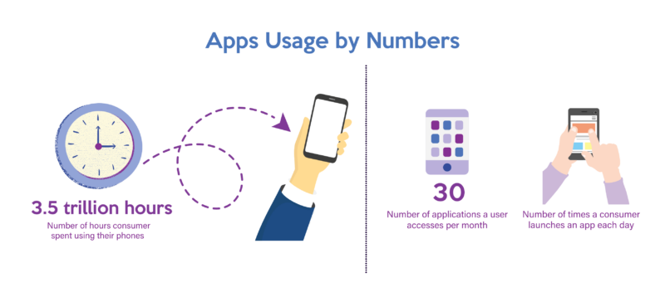

[Source](https://financesonline.com/uploads/2021/05/app-usage-by-the-numbers.jpg)

Look at the development cost, benefits, and potential risks, and find a balance that works for your brand. When in doubt, chat with an experienced outsourcing provider to learn your options.